Aria melanie lee
Naming ceremony

4th november 2017

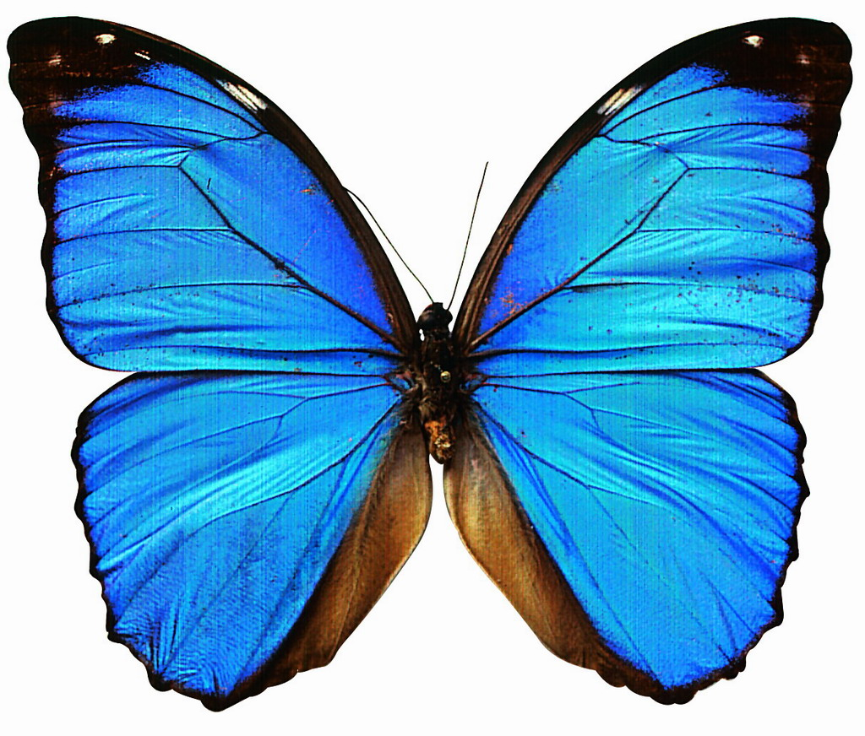

Aria's Date of birth: 4th november 2016

